Design Changes

- For U1 LM5160ADNTR the requirement is 3.8V at the output of the flyback transformer. To obtain the required voltage at the output of the transformer we have to include forward voltage drop of the secondary rectifier diode as mentioned in the datasheet. So the voltage at the input of the the transformer, if transformer with turns ratio of 1 : 1.5 (N1:N2) is selected is calculated to be 3.0V according to the Equation 22 Pg# 24 of the LM5160ADNTR datasheet.

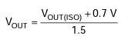

- Change R31 to 100KΩ to set Fsw to 300Khz, as we have set the output voltage to 3.0V at the primary side of the transformer. LM5160ADNTR Datasheet Pg#19 Equation 12.

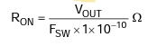

- Change R4 to 7.8KΩ for the feedback network to achieve 3.0V at the output on the primary side of the flyback transformer. The transformer will then step up the voltage and provide the isolated 3.8V at the output.

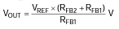

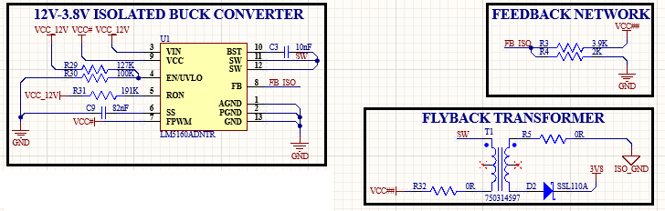

- Verify the parts value of R38 and R41 in PCB and BOM files because these resistors were swapped during manufacturing to avoid this error. It is advised to also change the labels position for visual verification as the labels position are swapped between these.

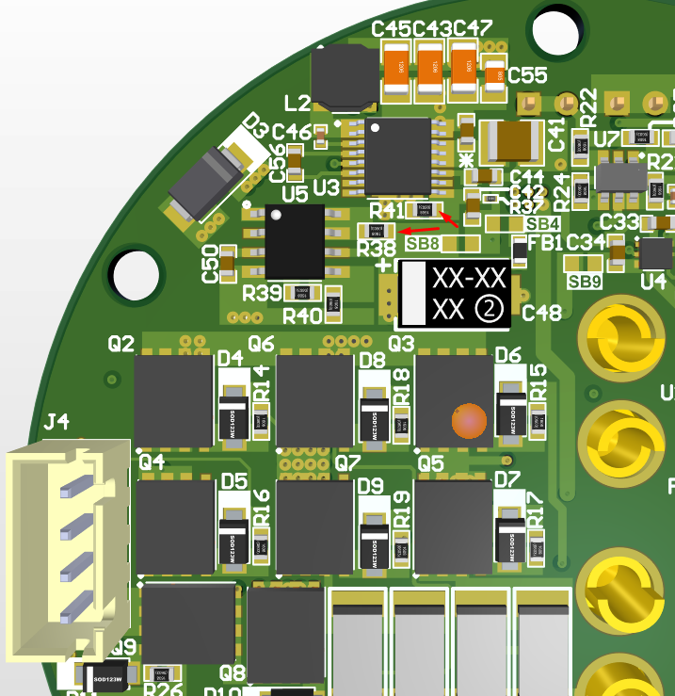

- Correct footprint for component T1 (750314597) from schematics.

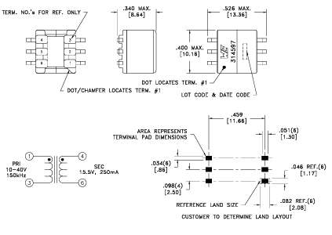

- The connector J3 in the top board and its pins are vertically flipped in the schematics due to which the connector designated pins do not match. The orientation and rotation of the connector itself is physically correct on the PCB and the notch of both connectors are matching.

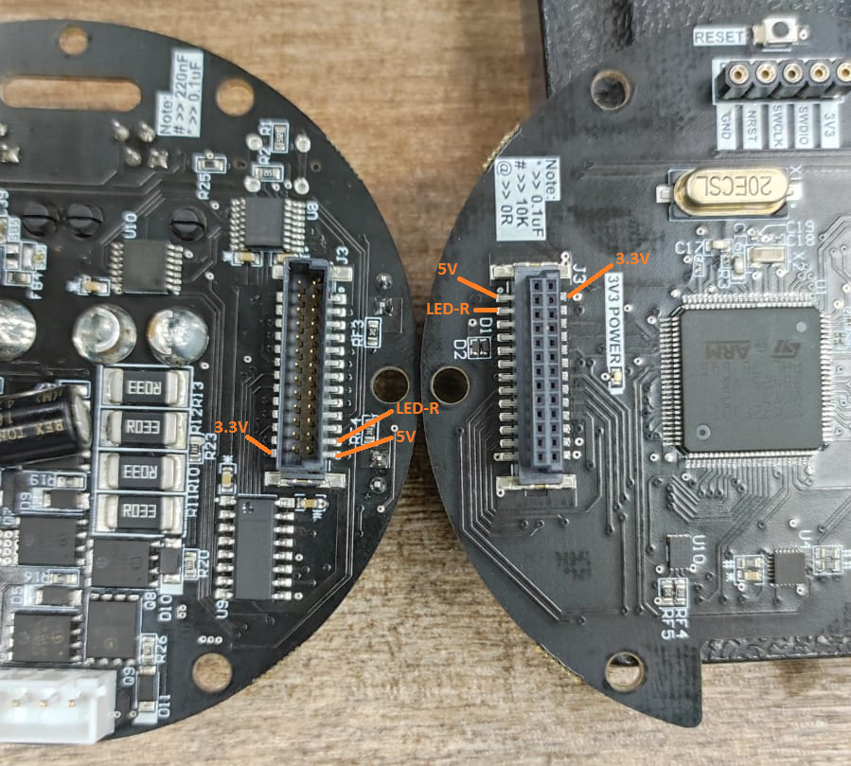

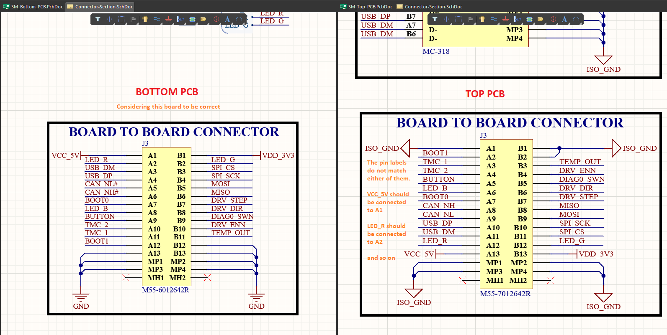

- In the RGB LED LTST-G683GEBW top board, the current limiting resistor on the RED LED is missing. Add a resistor of 560Ω to it.

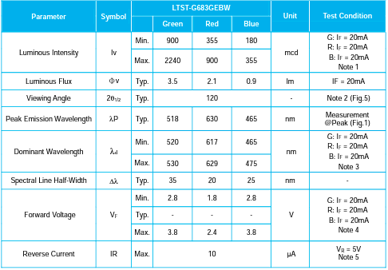

- Change the location of Solder Bridge SB11 as the area is very narrow to bridge the solder.

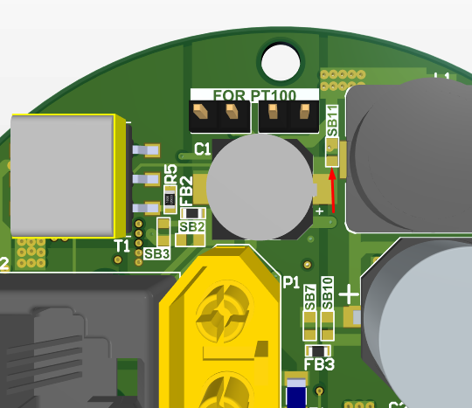

- Designators missing on PCB Top board top layer.

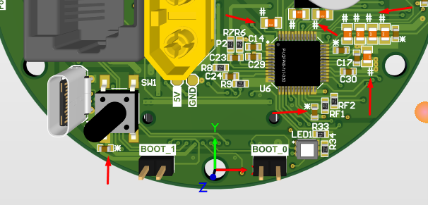

- Designators missing on PCB Top board bottom layer.

